

# **PRG001** **Programming**

# **Assignment 3 - 201801**

**Name:**

**SAIBT ID:**

## This is my own work as defined by the SAIBTs Academic Integrity and Misconduct Policy: Signed: __________________________________

Contents

1. Analysis 3

1.1. Problem Definition 3

1.2. Research - Useful webpages 3

2. Design 4

2.1. Page design 4

2.2. Content 5

2.3. Algorithm 6

3. Implementation 7

3.1. Screenshots 7

3.2. Programming Code (attached) 7

4. Testing 8

4.1. Test 1 8

4.2. Test 2 8

4.3. Test 3 8

4.4. Test 4 8

4.5. Test 5 8

1. Analysis

This assignment needs to create two webpages, which are the home page and the quiz page.

* 1. Problem Definition

Inputs:

* Introduction for HTML
* Links for HTML Tutorial
* Introduction for JavaScript
* Links for JavaScript Tutorial
* Ten questions based on HTML and JavaScript
* User’s answer for questions

Outputs:

* Show introduction for HTML on home page
* Show introduction for JavaScript on home page
* Show Links for HTML Tutorial on home page
* Show Links for JavaScript Tutorial on home page
* Show ten questions on quiz page
* Show user’s test result on quiz page with judged score

Constraints:

* User’s inputs must conform to the answers for questions  
  1. Research - Useful webpages

HTML

1. *<https://html.com/>*
2. *<https://www.w3.org/html/>*
3. *https://developer.mozilla.org/en-US/docs/Web/Tutorials*

JavaScript

* 1. *<https://developer.mozilla.org/en-US/docs/Web/JavaScript/Reference/Global_Objects/Math/random>*
  2. *<https://stackoverflow.com/questions/18806210/generating-non-repeating-random-numbers-in-js>*
  3. *https://developer.mozilla.org/en-US/docs/Web/JavaScript*

1. Design
   1. Page design

Home page

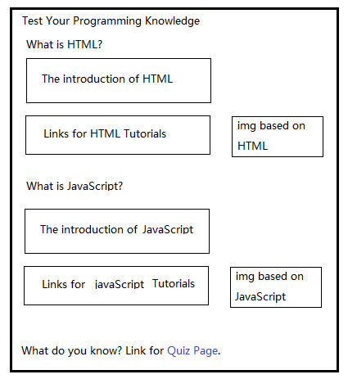

Questions

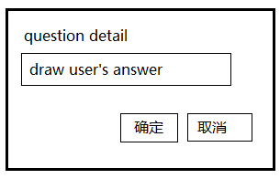

Feedback

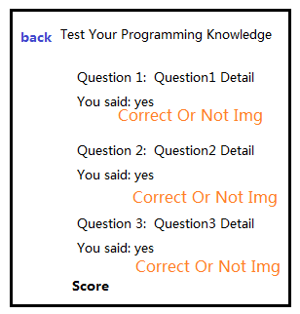

* 1. Content

**Questions on JavaScript/HTML**

|  |  |
| --- | --- |
| Question | Answer |
| 1. Can \"<input type='submit' />\" represents a button? Use yes or no to answer. | yes |
| 1. What function can we use to delete element from array and also insert elements into array? | splice |
| 1. How can we create a random number between 0-9? | Math.floor(Math.random()*10) |
| 1. What function can we use to bind an event to document elements in chrome browser? Just list function name. | addEventListener |
| 1. What html tag can we use to insert an image into web page? Just list tag name. | img |
| 1. What html tag can we use to create an hyperlink? Just list tag name. | a |
| 1. Does html tag must have a closing tag like XML? Use yes or no to answer. | yes |
| 1. What html tag can we use to create a form? Just list tag name. | form |
| 1. Is javascript a weak-typed language? Use yes or no to answer. | yes |
| 1. What is the result for 2&&3? | 3 |

**Information**

**HTML**

HTML is short for HyperText Markup Language and it is used to create webpages which will be displayed on the World Wide Web. It help to build the stucture for the webpage. It has a series of tags, such as div, table, span, p, img, form, input and so on. Now the latest w3c html standard is HTML5, which added many semantic Tags, such as article, section, aside, header, footer, etc.HTML ensures the proper formatting of text and images so that your Internet browser may display them as they are intended to look. Without HTML, a browser would not know how to display text as elements or load images or other elements. HTML also provides a basic structure of the page, upon which Cascading Style Sheets are overlaid to change its appearance.

Examples:

HTML code: <h4 class="h4">What is HTML?</h4>

appearance:



**JavaScript**

JavaScript is a scripting or programming language that allows you to implement complex things on web pages — every time a web page does more than just sit there and display static information for you to look at — displaying timely content updates, interactive maps, animated 2D/3D graphics, scrolling video jukeboxes, etc. — you can bet that JavaScript is probably involved. It is the third layer of the layer cake of standard web technologies.JavaScript is an interpreted, object-based scripting language. Although it has fewer capabilities than full-fledged object-oriented languages like C++, JavaScript is more than sufficiently powerful for its intended purposes.JavaScript is not a cut-down version of another language (it is only distantly and indirectly related to Java, for example), nor is it a simplification of anything. It is, however, limited. You cannot write stand-alone applications in it, for example, and it has no built-in support for reading or writing files. Moreover, JavaScript scripts can run only in the presence of an interpreter or "host", such as Internet Explorer. JavaScript is a loosely typed language. Loosely typed means you do not have to declare the data types of variables explicitly. In fact, JavaScript takes it one step further. You cannot explicitly declare data types in JavaScript. Moreover, in many cases JavaScript performs conversions automatically when needed. For instance, if you add a number to an item consisting of text (a string), the number is converted to text.

Examples:

Define variables

1. Number type

var a = 1;

1. Array type

var b = []

**Algorithm**

[pseudocode](http://youdao.com/w/pseudocode/" \l "keyfrom=E2Ctranslation):

1. Bind a onload event to window
2. Implement the onload callback as follows:
3. Define global variables:

Define an array called questions to contain ten questions, an array called answers to contain the answers to questions, an array called msg to contain the final messages based on sore, an array called results to contain user’s answers.

1. An shuffle function to implement random questions
2. Define an loop to prompt question and get user’s answer.
3. Define a function to show final message based on user’s score.
4. Implementation
   1. Screenshots

**Home page:**

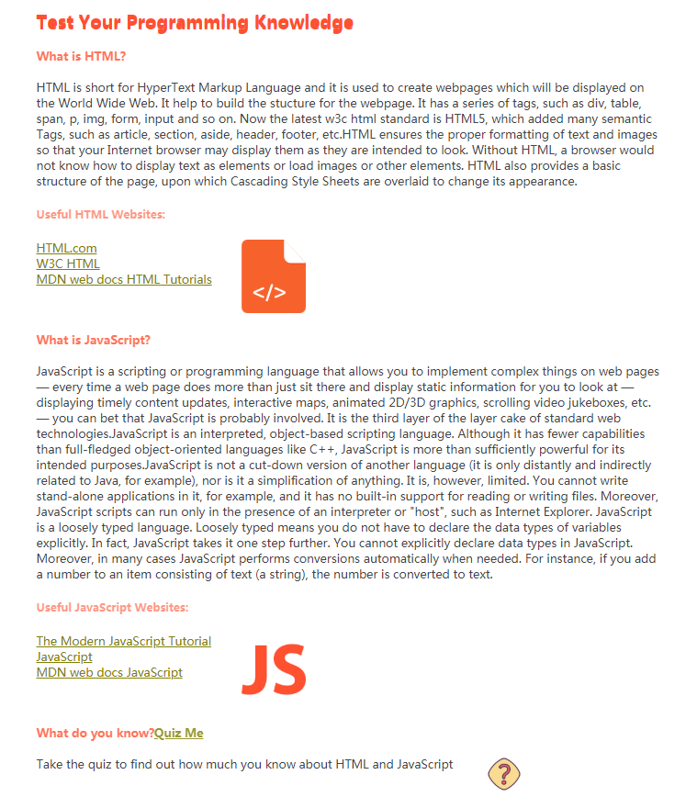

**Question page:**

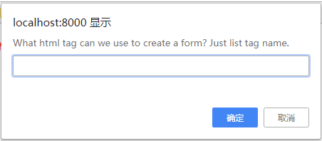

**Feedback page:**

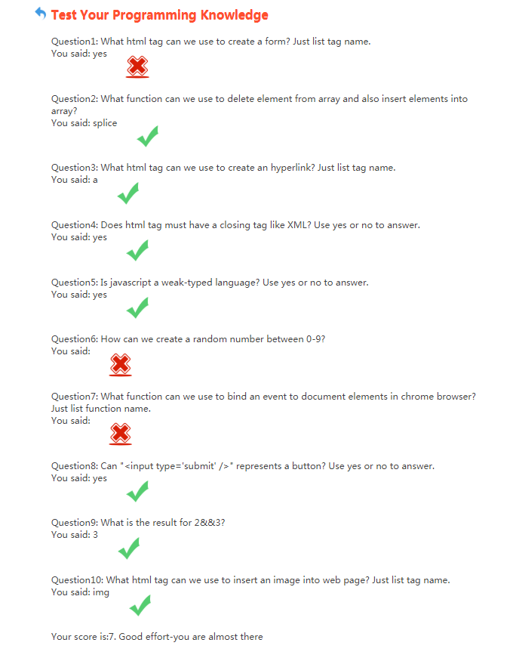

* 1. Programming Code (attached)



3.3 Testing

* 1. 3.3.1 Test 1

Purpose of test: Determine if the link to the home page can be skipped normally.

Actions required: Click the link such as HTML.com  
Expected results: Jump to the link which is “https://html.com/” correctly  
Actual results: As expected results

Problems found: Nothing

3.3.2 Test 2

Purpose of test: Determine the home page is normal when resize

Actions required:Resize the browser’s window size  
Expected results: The main part of the page is always in middle  
Actual results: As expected results

Problems found:Nothing

* 1. 3.3.3 Test 3

Purpose of test: Determine whether can jump to quiz page normally when click on ‘Quiz Me’.

Actions required: Click ‘Quiz Me’  
Expected results: Jump to question page normally.  
Actual results: As expected results

Problems found: Nothing

* 1. 3.3.4 Test 4

Purpose of test: Determine whether the question page can judge user’s answer correctly.

Actions required: Go to question page to answer the ten questions.  
Expected results: Show correct image when user’s answer is correct, Show wrong image when user’s answer is wrong.  
Actual results: As expected results

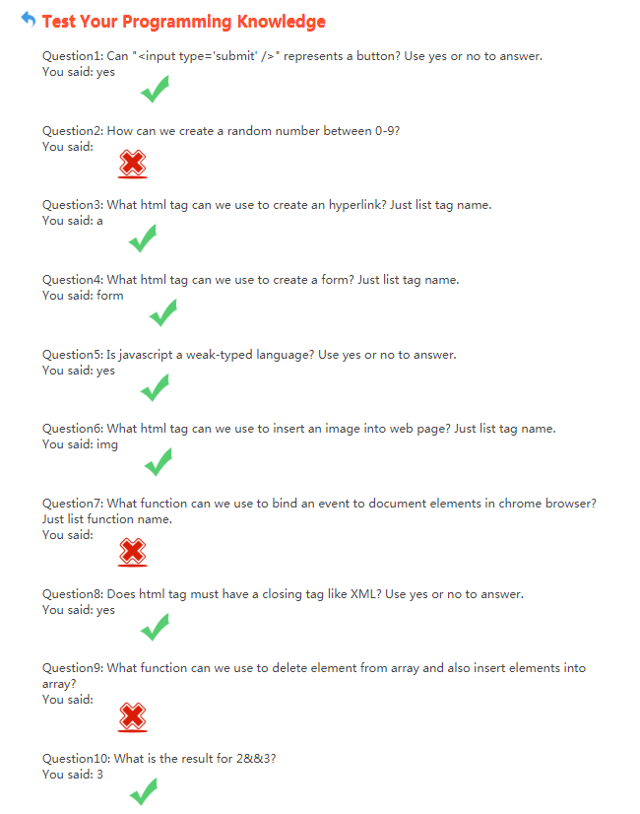

Problems found: Nothing

* 1. 3.3.5 Test 5

Purpose of test: Determine whether final message is correct based on score.

Actions required: Answer all of the ten questions.  
Expected results: Show the final message.  
Actual results: As expected results



Problems found: Nothing